Dear Colleagues!
You are welcome to take part in
ХII International Science and Technology
Conference
ADVANCED METHODS AND TECHNOLOGIES OF MATERIALS DEVELOPMENT AND PROCESSING
September 13–15, 2017, Minsk, Belarus
CONFERENCE SECTIONS:
- Constructional and functional materials in up-to-date engineering
- Surface engineering technologies and equipment
- Casting technological processes of metal forming
DEADLINES
Submitting applications and papers May 2, 2017
Receipt of registration fee August 1, 2017
Arrival of participants September 13, 2017
Work of the Conference September 13–15, 2017
Departure of participants September 15, 2017
CONFERENCE PARTICIPATION FORMS
1. Full-time participation:
- plenary reports
- section reports
2. Correspondence participation (for foreign citizens only)
INFORMATION FOR PARTICIPANTS
The submitted papers are subject to obligatory reviewing. The papers are sent to the reviewer upon receipt of letters of guarantee on registration fee payment from the corresponding organizations. One author is allowed submitting no more than two papers.
In order to participate in the Conference one needs to submit to the Organizing Committee an application form, report materials (1 hard copy), a letter of guarantee on registration fee payment, as well as send an electronic copy of the application form and the report materials to phti.conference@gmail.com.
The Organizing Committee reserves the right to reject papers upon a negative review. The papers that do not comply with the regulations and are received later than May 2, 2017 are not to be reviewed or returned.
The Conference working languages are Russian and English.
ORGANIZING COMMITTEE
V.G. Zalesski (Chairman)
A.T. Volochko (Vice Chairman)
A.V. Byeli (Vice Chairman)

L.R. Vishnyakov (Ukraine)  A.I. Gordienko (Belarus)  I. G. Goryacheva (Russia)  A.P. Dastanko (Belarus)  O.M. Ivasishin (Ukraine)  A.F. Ilyushchenka (Belarus)  V.V.Klubovich (Belarus)  A.P. Laskauniou (Belarus)  A. I. Mihlyuk (Belarus)  Y.I. Marukovich (Belarus)  N.K. Myshkin (Belarus)  V.Y. Ovcharenko (Russia)  F.I. Panteleyenka (Belarus)  S.G. Psahyie (Russia) | N.M. Rasulov (Azerbaijan)  D. Rigney (USA)  A.I. Sviridzionak (Belarus)  R. Stonis (Lithuania)  P.V. Utyupin (Belarus)  V.M. Fedasyuk (Belarus)  S.A. Chizhik (Belarus)  V.N. Chuvildeyev (Russia)  Ki Young Choi (South Korea)  B.M. Khrustaliou (Belarus)  V.K. Sheleg Belarus)  A.G. Shumilin (Belarus)  H. Dyja (Poland)
PROGRAM COMMITTEE
A.T. Volochko (Chairman)
O.A. Poka (Vice Chairman)
S.D. Latushkina, A.I. Pokrovskiy

ORGANIZING COMMITTEE ADDRESS
Kuprevich 10 St., 220141, Minsk,
Republic of Belarus; tel./fax (375 17) 369-76-93
CONTACT INFORMATION
Executive Secretary:
Anna A. Broukina
Tel. (375 17) 268-11-94;
E-mail: market_phti@belhost.by
The person responsible for registration of applications:
Pobiarzhyna Natallia,
Tel. (375 17) 369-86-64; E-mail: phti.conference@gmail.com
REGISTRATION FEE

The payment of registration fee includes costs of services, reviewing and publication of the materials and
- for full-time participation authors it is a sum equivalent to 150 USD including VAT of 20%;
- for correspondence participation authors it is a sum equivalent to 75 USD including VAT of 20%.

The payment of registration fee entitles the (composite) author to receive one book of the Conference Proceedings.
In payment order in column “Payment function” it should be pointed out:
Registration fee for participating in Conference «Advanced Methods and Technologies of Materials Development and Processing» Last and first name of the participant.
Besides, it is necessary to send a copy of the payment order about the transfer of registration fee.
Payment requisites:

Beneficiary: The State Scientific Institution «Physical Technical Institute of the National Academy of Sciences
of Belarus»; 220141, Belarus, Minsk, 10 Kuprevich Street

Beneficiary bank:
JOINT STOCK COMPANY «SAVINGS BANK BELARUSBANK» BRANCH № 514
SWIFT – AKBBBY21514
for transferring to account с 3632915230016 (840)

Correspondent bank:
CITIBANK N.A., New York, SWIFT – CITIUS33,
Acc. 36316365
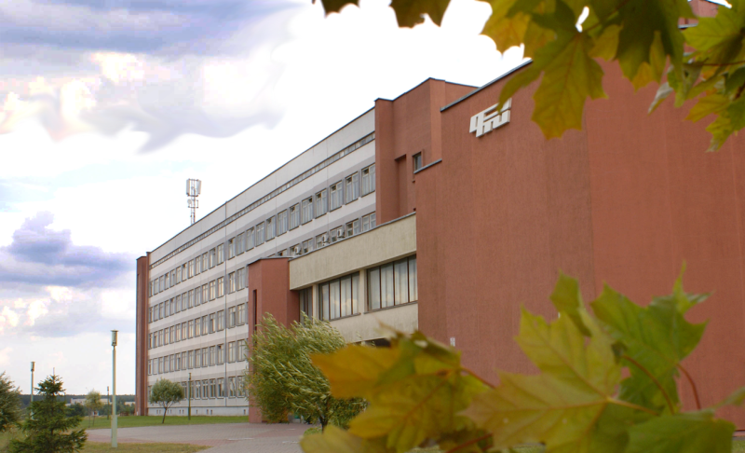
Application form
(Submitted by 02.05.2017)*

for participation in the XII International
Scientific-Technical Conference
Advanced methods and technologies for materials development and processing
September 13–15, 2017, Minsk, Belarus
Author presenting the paper:
Last name _________________________________ First name _________________________________
Academic degree ___________________________
Academic rank _____________________________
Position ___________________________________
Paper title and authors ______________________
___________________________________________
___________________________________________
___________________________________________
___________________________________________
in Conference section No. ____________________
Participation in the Conference: full-time or correspondence (please, underline)
Organization (full and abbreviated name) _____
___________________________________________
___________________________________________
___________________________________________
___________________________________________
Mailing address ____________________________
___________________________________________
___________________________________________
Telephone ____________ Fax _________________
E-mail _____________________________________
Hotel reservation
Please tick if necessary:
● Yes (a room for one or two persons, approximate date of check-in)
● No
Signature_______________ Date ______________
* An application can be copied from www.phti.by/conference
Guidelines for preparation of paper materials

1. The text of the report shall be typed using Microsoft Word editor, one column, font Times New Roman – 11 pt; single-space typing; margins should be 2.5 cm, book orientation.
2. The initials and names of authors are typed in the right top corner of the first page; the paper title is centered and typed in all capital letters (font Times New Roman, 13 pt, bold face) then comes organization name, at the next line city and state (in lowercase letters) followed double-line space below by abstract that should not exceed 10 lines. The paper text is typed double-line space below the abstract with new indent using one interword blank.
At the next line are typed keywords.
After the keywords specified E-mail the author / authors.

3. Figures and diagrams are made black-white; they shall be saved as TIFF, EPS, JPEG types of files and have resolution 300 dpi.
4. The text of a report shall not exceed 10 pages of A4 format including an abstract, a text, tables, graphs, diagrams (histograms), figures, legends and references.
The guidelines for reports can be read here: www.phti.by/conference
Reports transmission
1. The text of the report shall be sent to phti@tut.by with figures saved as separate files. The name of the file with the text shall have the name of the reporter and the two words from the name of the report.
2. The report on paper shall be submitted in two copies in A4 format with the signature of the author to the Organizing Committee.

national academy of sciences of Belarus
MinIstry of industry of the republic of belarus
State committee of science and technologies
of the republic of belarus
physical-technical institute
of national academy of sciences of belarus

XII INTERNATIONAL scientific-TECHNICAL CONFERENCE

advanced methods and technologies of materials development and processing

September 13–15, 2017
Minsk, Republic of Belarus

Announcement-Invitation

